Emergency Incident and/or Injury Procedures

Incident, Injury, and/or Emergency:
If there is any form of incident, injury, or emergency:
- Stop all procedures safely.
- Seek Medical help by calling 7-5911 from the phone on the wall IMMEDIATELY.
  - Note: Automated External Defibrillators (AEDs) are located by the main elevator lobby (across the courtyard).
- Utilize eyewash/safety shower.
- Utilize the First Aid Kit to administer aid (only if it is a minor cut with no risk of exposure).

Post Incident, Injury, and/or Emergency Actions:
- Immediately Contact the Supervisor/Manager.
  - [ENTER CONTACT INFORMATION HERE]
- Report Injuries /Accidents
  - To Human Resource (worker compensation): http://hrapps.fiu.edu/Injury/
    - After regular work hours or on the weekends, call the medical provider directly to file a claim: AmeriSys at 800-455-2079.
  - To Environmental Health & Safety (EH&S): https://ehs.fiu.edu/report/index.html
  - If applicable, report blood-borne pathogen injuries to EH&S here: https://webforms.fiu.edu/view.php?id=992783

Incidents and Near Misses
Report Incidents or Near Misses to EH&S: https://ehs.fiu.edu/report/index.html

QR Codes for Quick Access

Human Resources Injury/Accident Claim Report | Report Blood-borne Pathogen Injury
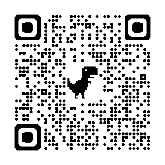 | 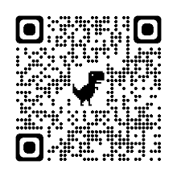
EH&S Health & Safety Reporting Form
